- Create a simple cloud software application and provide it as a service using any Cloud Service Provider to demonstrate Software as a Service (SaaS).

Aim:
To create and deploy a simple web application on a cloud platform and provide it as a service over the internet, demonstrating the Software as a Service (SaaS) model.

Procedure:
Log in to Zoho Creator.
Create a new application.
Design a simple form (e.g., Student Details or To-Do List).
Add the required fields and save the form.
Publish the application to the cloud.
Generate the application URL.
Access the application through a web browser.
Verify that users can use the application online as a SaaS service.

Output:

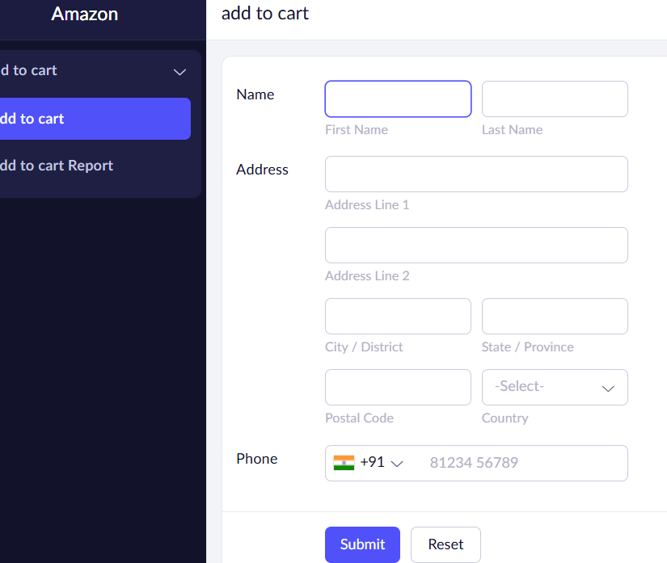

Result:
A simple application was successfully created and deployed using Zoho Creator, demonstrating the Software as a Service (SaaS) model.

